

**FNDB020 Accounting**

**Workbook Answers**

Lecture and Tutorial

**Week 9: Accounting for Inventories**

**Part I**

**Updated April 2016**

# FND0B020 Lecture Week 8: Accounting for Inventories (Part I)

**Service Provider Vs Retailer**

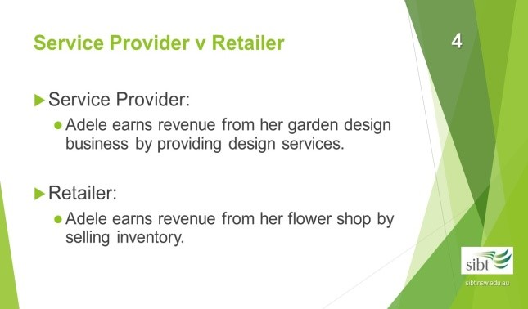

Business entities can be classified generally into services, retailing and manufacturing businesses. A retailing business is one that acquires (buys or purchases) goods for resale at either the wholesale or retail level. The inventory of such a business is commonly referred to as stock or inventory.

Accounting for the inventory involves *determining* the cost of inventory to be deducted from sales as the cost of sales. The basic format of an income statement for retail

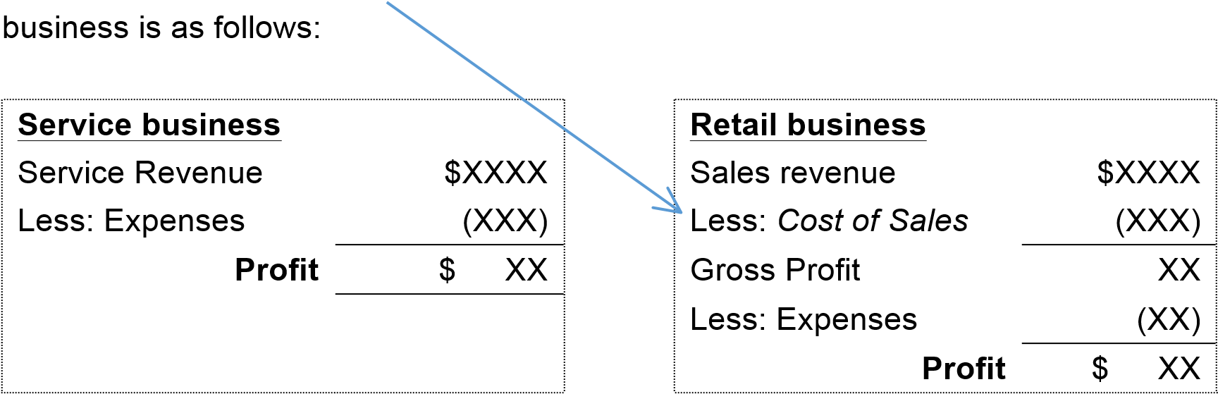

Service Provider:

The main business activity is to provide services.

Retailer:

The main business activity is to purchase and resell inventory.

A service business’s income statement usually involves a single step between revenue and profit. The income statement of a retail business, however, involves **multiple steps** in the determination of profit.

## Inventory

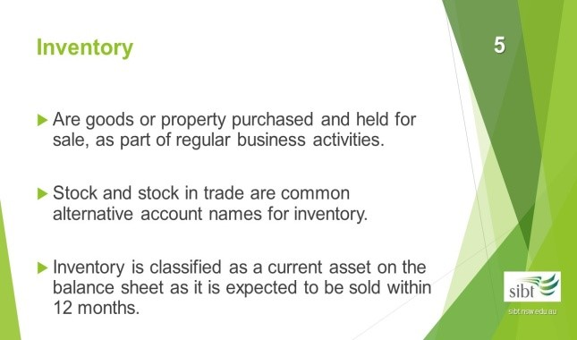

* The nature of Adele’s flower shop business requires her to account for goods purchased for resale. The term inventory is used to describe such goods in a retail business.

* Stock and stock in trade are common alternative terms for inventory.

* Inventory is classified as current asset because it is expected to be sold within 12 months.

(Note: the effect of GST needs to be considered for each business transaction for Adele’s flower shop. You are not required to do GST adjustment for discounts in this course.)

|  |  |
| --- | --- |
| **Exercise 9.1** | Business Entities |

Adele has decided to set up her flower shop as a sole trader. What do you think are the main reasons for her decision?

|  |
| --- |
| Advantages of a sole trader business:  1. The set-up cost is low. 2. Owner has full control.   1. Owner retains all profit. 2. This structure is suitable for a small business with lower running costs. |

|  |  |
| --- | --- |
| **Exercise 9.2** | Inventory definition |

1. What inventory does Adele carry in her garden design business?

Adele does not need inventory for her garden design business because she provides service to receive income.

1. What inventory does Adele carry in her flower shop?

Anything for resale goods should be treated as inventory. E.g. fresh flowers, plants, vases, pots, cards, packing materials

1. Adele has a cash register in her shop and she uses her laptop to record business transactions. Are these items inventory? How should Adele account for these items?

Both the cash register and the laptop are not inventory because they are not goods for resale. They are assets of the business and can be reported as non-current assets on the balance sheet.

1. Adele also stocks 8 bottles of liquid fertilizer in her store. She applies the fertilizer to the plants for sale. She usually does not sell the fertilizer but occasionally she sells it to frequent customers. Is the liquid fertiliser inventory? How should Adele account for the liquid fertiliser?

The liquid fertiliser is not inventory because Adele does not intend to resell them. The occasional sale does not form part of the regular business activities. The cost of the liquid fertiliser can be treated as an expense.

## To Allocate the Cost of Inventory

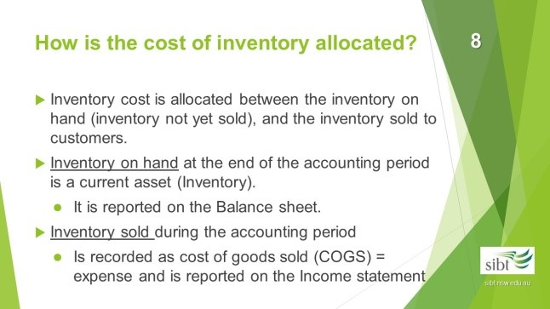

One main issue of inventory accounting is to allocate the **cost** of inventory between, inventory on hand and cost of goods sold:

* Inventory on hand is recorded in the account **“inventory”** on the *balance sheet* as a current asset. This is business assets ready (waiting to be) for sale;

* This is inventory that has been sold. Inventory sold will be taken out of ‘stock’ and recorded in the account **“cost of goods sold”** in the *income statement* as an expense.

**‘Inventory’** or **‘cost of goods sold’** are recorded using the **same** cost price.

|  |  |
| --- | --- |
| **Exercise 9.3** | Allocation of cost of inventory |

Adele purchased 600 roses for $1,800 ($3 cost price per rose). She sold 550 of them and still has 50 on hand at the end of the financial year. How is the $1,800 cost of the roses allocated between inventory on hand and cost of goods sold?

1. 50 roses on hand

The 50 roses in stock are ready for sale and can be converted into money in the future. They should be treated as assets on the balance sheet. We use the account “inventory” to record the cost of roses on hand. At the end of the financial year, the inventory account balance should contain $150 ($3*50) of roses on hand.

1. 550 roses sold

The 550 roses sold are no longer in stock. The cost represents the consumption of economic benefits and should be treated as an expense. On the income statement of a retailer we use the account “cost of goods sold (COGS)” to record the cost of sold inventory. On the income statement for this financial year the COGS account should include $1,650 ($3*550) of roses sold.

**The**

**Income Statement of a Retailer**

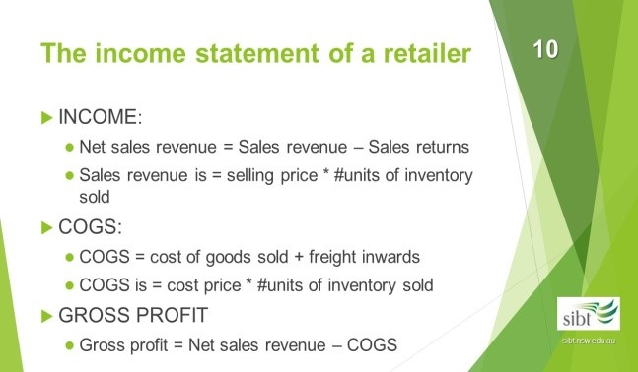

1. **Income:**

Net sales revenue = Sales revenue – Sales returns

* + Sales revenue = number of units sold x selling price
  + Sales returns occur when goods previous sold are returned by a customer. An adjustment note (a credit note) is issued to the customer. The adjustment note serves as a negative invoice. The sales returns are recorded in a contra sales account called “Sales returns and allowances”.

1. **Cost of goods sold (COGS):**

COGS = cost of inventory sold + freight inwards

* + Cost of goods sold = number of units sold x cost price.
  + Freight inwards: cost paid by the buyer to move goods from the seller’s place to the buyer’s place.

1. **Gross Profit**

Gross profit = Net sales revenue – COGS

1. **Operating Expenses:**

* 1. Selling and distribution expenses

The expenses represent efforts to sell inventory. E.g. Storage costs, advertising, sales commission, and cost of delivering goods to the customer (freight outwards).

* 1. Administrative expenses

Expenses associated with operating the general office, accounting systems and personnel. E.g. rent, utilities, salary for admin.staff, office suppliers and insurance.

* 1. Finance expenses

Expense of financing the business’s operations, collecting debts, e.g. interest and bad debts. Note that other expenses may also be included under the category “finance and other expenses”

1. **Net profit:**

Net profit = Gross profit – Total expenses

|  |  |
| --- | --- |
| **Exercise 9.4** | To calculate net profit |

Adele earned total revenue of $133,810 for the financial year ended 30 June 2017. The sales return is $3,880. Adele recorded the cost of sold inventory is $53,410. She also paid $1,230 freight to get all goods delivered to her shop. The expenses are as follows:

|  |  |
| --- | --- |
| EXPENSES: |  |
| Selling and distribution expenses | $12 730 |
| Administrative expenses | $7 750 |
| Finance expenses | $960 |

Calculate the following:

1. gross profit

Net sales revenue = 133,810 – 3880 = 129,930

COGS = 53,410 + 1,230 = 54,640

Gross profit = 129,930 – 54,640 = 75,290

1. net profit

Net profit = 75,290 – 12,730 – 7,750 – 960 = 53,850

|  |  |
| --- | --- |
| **Exercise 9.5** | The income statement of a retailer |

Using the information in Exercise 9.4, prepare an income statement for Adele’s flower shop for the year ended 30 June 2017.

|  |  |
| --- | --- |
| **Adele’s Flower shop**  **Income Statement for the year ended 30 June 2017** |  |
| INCOME  Sales Revenue: | $133 810 |
| *Less:* Sales returns and allowances  Net sales revenue | $3 880 |
| $129 930 |
| Cost of sales:  GROSS PROFIT | $54 640 |
| $75 290 |
| EXPENSES:  Selling and distribution expenses $12 730  Administrative expenses $7 750  Finance expenses $960    PROFIT | $21 440 |
| $53 850 |
|  |

## Accounting for Cash Discounts

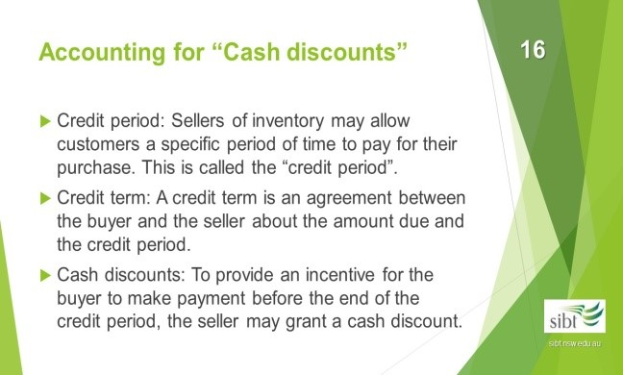

**A. Credit period**

Sellers may allow payments by the buyers to be delayed for a specific length of time, called the “credit period”.

**B) Credit term**

A credit term is an agreement between the buyer and the seller about amount due and the credit period.

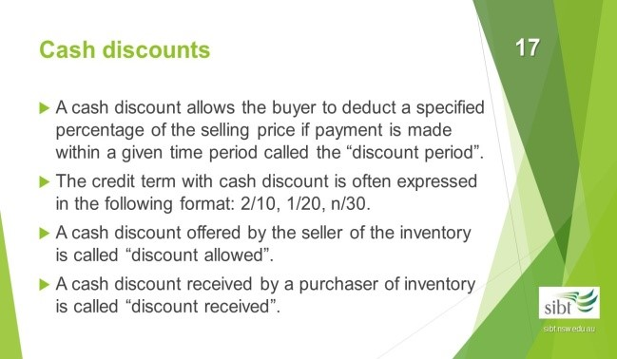

**B. Cash discounts**

To provide an incentive for the buyer to make payment before the end of the credit period, the seller may grant a cash discount.

A cash discount allows the buyer to deduct a specified percentage of the selling price if payment is made within a given time period called the “**discount period**”.

The credit term with cash discount is often expressed in the following format: 2/10, 1/20, n/30.

* 2/10: a 2% discount will be allowed if the debt is paid within 10 days.
* 1/20: a 1% discount will be allowed if the debt is paid within 20 days.
* n/30: no discount will be allowed and the payment is due within 30 days.

1. Discount allowed:

This allows the accounts receivable customers to pay less than the amount on the invoice for early settlement. This is an expense.

1. Discount received:

The business is entitled to pay less than the invoice amount to their supplier for early payment of accounts payable. This is income.

|  |  |
| --- | --- |
| **Exercise 9.6** | To record cash discount |

Adele sold fresh flowers to a customer on 1 April on credit for $500 plus GST To encourage early payment, Adele provided the credit terms: 2/10, 1/20, n/30, The customer paid on 9 April. How should Adele record the credit sales?

Because the payment is made within 10 days, 2% discount is allowed to the customer. The discount is 500*2%=10. How should Adele record the payment receipt?

|  |  |  |  |
| --- | --- | --- | --- |
|  | **General Jou** | **rnal** |  |
| **Date** | **Details** | **Debits** | **Credits** |
| 1 Apr | Accounts receivable | 550 |  |
|  | Sales revenue  GST Collection |  | 500 50 |
|  | (Credit sale of flowers) |  |  |
|  |  |  |  |
| 9 Apr | Cash at bank | 539 |  |
|  | Discount allowed (2%*550) | 11 |  |
|  | Accounts receivable |  | 550 |
|  | (Cash receipt within discount period) |  |  |

**Note:** GST should also be recorded for discounts but you are not required to do GST adjustment for discounts in this course.

## Accounting for Inventories – Perpetual Inventory System

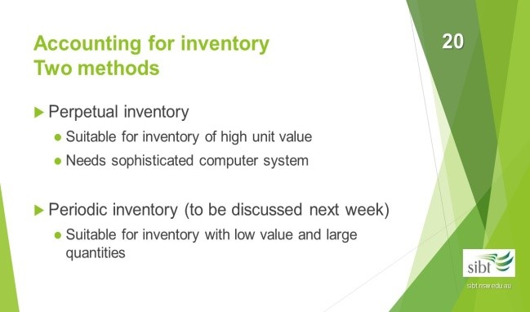

In the past the perpetual inventory system is used for inventory of high unit value (e.g. vehicles, whitegoods). With the development of sophisticated computer system the perpetual inventory system has become more popular. The periodic inventory system will be introduced next week

**A.**

**I**

**n a perpetual inventory system**

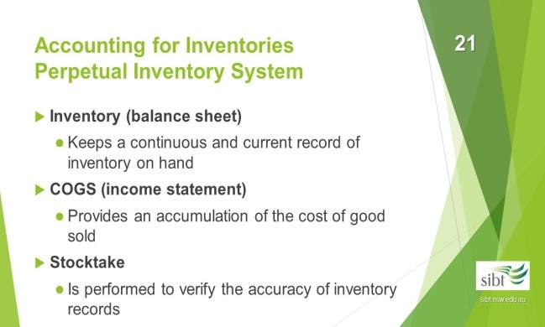

1. The inventory account on the balance sheet provides a continuous and current record of inventory on hand. The inventory balance is updated with each purchase and sale transaction.

1. A perpetual system provides for an accumulation of the cost of goods sold during the period. The cost of goods sold is recorded at each sale and reversed for each sale return.

1. A stocktake is a physical count of the inventory on hand. It is performed under a perpetual inventory system to verify the accuracy of the recorded ending inventory balance. Any losses of inventory caused by theft, shrinkage, breakage and clerical error can by identified through a stocktake.

**B. Inventory card:**

An inventory card is kept for each type of inventory item held. It keeps a current and continuous record of all inventory transactions. For example, Adele keeps the following inventory card for her 40cm roses:

|  |  |  |  |  |  |  |  |  |  |  |
| --- | --- | --- | --- | --- | --- | --- | --- | --- | --- | --- |
|  | | **Adele’s Flower shop – Inventory Card** | | | | | |  |  | |
| Item: Rose (40cm) | |  | | | | | |  |  | |
| Code: R40 | | Purchases | | | Sales | | |  | Balance | |
| Date | Explanation | Units | Unit cost | Total cost | Units | Unit cost | Total cost | Units | Unit cost | Total cost |
| 1/7 | Opening Bal |  |  |  |  |  |  | 0 | 3 | 0 |
| 15/7 | Purchases | 300 | 3 | 900 |  |  |  | 300 | 3 | 900 |
| 17/7 | Purchases returns | (20) | 3 | (60) |  |  |  | 280 | 3 | 840 |
| 24/7 | Sales |  |  |  | 50 | 3 | 150 | 230 | 3 | 690 |
| 25/7 | Sales returns |  |  |  | (5) | 3 | (15) | 235 | 3 | 705 |

Note that the record only concerns the **cost** of inventory, even for the sales columns. The selling price is not recorded on the card. The sales columns disclose cost of sales and the balance columns show cost of inventory on hand.

|  |  |
| --- | --- |
| **Exercise 9.7** | Illustrate perpetual inventory system |

Assume Adele uses a perpetual inventory system for her flower shop. Prepare journal entries for the following transactions in July. Note: Cost price of each rose = $3 plus GST

Selling price of each rose = $6 plus GST

|  |  |
| --- | --- |
| **Exercise 9.7.1** | Illustrate perpetual inventory system Inventory purchase |

On 15 July, Adele bought 300 roses (40 cm) at $3 each plus GST on credit from her supplier, Paul’s nursery. Term: 2/10, 1/20, n/30.

|  |  |  |  |
| --- | --- | --- | --- |
|  | **General Jou** | **rnal** |  |
| **Date** | **Details** | **Debits** | **Credits** |
| 15 Jul | Inventory | 900 |  |
|  | GST outlays | 90 |  |
|  | Account payable |  | 990 |
|  | (Bought 300 roses at $3 each plus  GST, on credit) |  |  |

The inventory account is used to record the cost of the goods excluding the GST. GST is recorded separately in the GST outlays account. Adele needs to pay the purchase price plus GST when the payment falls due.

|  |  |
| --- | --- |
| **Exercise 9.7.2** | Illustrate perpetual inventory system Inventory return |

On 17 Jul, Adele returned 20 roses to Paul because the bud size was too small. How should Adele record the return?

|  |  |  |  |
| --- | --- | --- | --- |
|  | **General Jou** | **rnal** |  |
| **Date** | **Details** | **Debits** | **Credits** |
| 17 Jul | Accounts payable | 66 |  |
|  | Inventory |  | 60 |
|  | GST outlays |  | 6 |
|  | (Returned 20 roses at $3 each, back to the supplier) |  |  |

The inventory account is decreased by the cost of goods returned excluding the GST. The GST outlays account is reversed by the GST amount. Adele’s liability is decreased by the original purchase price plus GST.

|  |  |
| --- | --- |
| **Exercise 9.7.3** | Illustrate perpetual inventory system Sales of inventory |

On 24 Jul, Adele sold 50 roses (40 cm) at $6 each plus GST to a customer. Term: 2/10, 1/20, n/30. How should Adele record the credit sales?

|  |  |  |  |
| --- | --- | --- | --- |
|  | **General Jou** | **rnal** |  |
| **Date** | **Details** | **Debits** | **Credits** |
| 24 Jul | Accounts receivable | 330 |  |
|  | Sales revenue |  | 300 |
|  | GST collections |  | 30 |
|  | (Sold 50 roses at $6 each selling price plus GST, on credit) |  |  |
|  |  |  |  |
|  | Cost of goods sold | 150 |  |
|  | Inventory |  | 150 |
|  | (To record COGS and the reduction of inventory on hand at $3 cost price) |  |  |

When a perpetual inventory system is used, each sale requires two entries. One records the revenue from the sale. The selling price is used to record the sales. The other records the cost of the item sold as an increase (debit) in the cost of goods sold and a decrease (credit) in the inventory account on the balance sheet. The cost/purchase price is used to record COGS.

|  |  |
| --- | --- |
| **Exercise 9.7.4** | Illustrate perpetual inventory system  Payments made by Adele for credit purchase, with cash discount |

On the 24 Jul, Adele paid for the purchase made on 15 Jul, within the discount period and after the purchase return. How should Adele record the payment?

|  |  |  |  |
| --- | --- | --- | --- |
|  | **General Jou** | **rnal** |  |
| **Date** | **Details** | **Debits** | **Credits** |
| 24 Jul | Accounts payable (990-66) | 924 |  |
|  | Cash at bank |  | 906 |
|  | Discount received (924*2%) |  | 18 |
|  | (Payment made by Adele) |  |  |

(Note: GST should also be recorded for discounts but you are not required to do GST adjustment for discounts in this course.)

Adele purchased 300 roses and then returned 20. She still needs to pay the purchase price of the 280 roses plus GST. (280*3*(1+10%)=$924) Adele made the payment within 10 days and received the cash discount of 2%. The 2% is applied to the $924 payment.

|  |  |
| --- | --- |
| **Exercise 9.7.5** | Illustrate perpetual inventory system Sales returns by the customer |

On 25 Jul, a customer returned 5 roses from the 24 Jul sale. Assume that the 5 roses are still suitable for sale. How should Adele record the sales return?

|  |  |  |  |
| --- | --- | --- | --- |
|  | **General Jou** | **rnal** |  |
| **Date** | **Details** | **Debits** | **Credits** |
| 25 Jul | Sales returns | 30 |  |
|  | GST collections | 3 |  |
|  | Accounts receivable |  | 33 |
|  | (Sales return of 5 roses by customer, at $6 each selling price) |  |  |
|  |  |  |  |
|  | Inventory | 15 |  |
|  | Cost of goods sold |  | 15 |
|  | (returned 5 roses back to inventory at $3 each cost price) |  |  |

In a perpetual inventory system, each sales return also requires two entries in order to reverse the effects of the two entries made to record the original sale. The first entry records the sales return. Because it is assumed that the items are still suitable for sale, a second entry is necessary to eliminate the cost of sales previously recorded and restore the items to the inventory account.

|  |  |
| --- | --- |
| **Exercise 9.7.6** | Illustrate perpetual inventory system  Payment received by Adele for the credit sale, with cash discount |

On 30 Jul, Adele received payment for the sale on 24 Jul. The customer made the payment within the discount period and after the return. How should Adele record the payment received?

|  |  |  |  |
| --- | --- | --- | --- |
|  | **General Jou** | **rnal** |  |
| **Date** | **Details** | **Debits** | **Credits** |
| 30 Jul | Cash at bank | 291 |  |
|  | Discount allowed (297*2%) | 6 |  |
|  | Accounts receivable (330-33) |  | 297 |
|  | (payment received by Adele) |  |  |

(Note: GST should also be recorded for discounts but you are not required to do GST adjustment for discounts in this course.)

The customer purchased 50 roses and returned 5. The selling price plus GST of 45 roses (45*6*(1+10%)=$297) is receivable by Adele. The customer paid the amount within 10 days and enjoyed 2% cash discount. The discount applies to the $297 balance.

|  |  |
| --- | --- |
| **Exercise 9.7.7** | Illustrate perpetual inventory system: Inventory stocktake |

On 31 Jul, Adele performed a stocktake and discovered that 10 roses are missing from the stock. How should Adele record the inventory loss?

|  |  |  |  |
| --- | --- | --- | --- |
|  | **General Jou** | **rnal** |  |
| **Date** | **Details** | **Debits** | **Credits** |
| 31 Jul | Inventory Shrinkage Expense  (10*$3) | 30 |  |
|  | Inventory (10*$3) |  | 30 |
|  | (To record 5 missing inventory at  $3 each cost price) |  |  |

The lost inventory reduces the inventory on hand and is recorded as inventory shrinkage (an expense).

Tutorial

# Week 9

1. **MID SEMESTER EXAM PAPER REVIEW**

## 2. LECTURE 9 REVISION (PRACTICE QUESTIONS)

|  |  |
| --- | --- |
| **Exercise 9.1** | Illustrate perpetual inventory system Journal entries |

Anne’s Computers buys and sells laptops. Anne purchases the laptops for $1,500 each plus GST and sells them for $2,200 each including GST. Record the following transactions under a perpetual inventory system:

1. Jun Purchased 10 laptops on credit, terms 2/10, n/30
2. Jun Returned 1 of the laptops purchased on credit on 1 June

5 Jun Sold 3 laptops on credit , terms 1/7, n/30

1. Jun The customer returned 1 laptop from the June 5 sale
2. Jun Paid the balance owing on the 1 June purchase

11 Jun Received payment from the customer for the balance owing on the 5 Jun sale 15 Jun Performed a stocktake and discovered that 1 laptop was missing.

|  |  |  |  |
| --- | --- | --- | --- |
| **General Journal** | | |  |
| **Date** | **Details** | **Debits** | **Credits** |
| 1 Jun | Inventory | 15,000 |  |
|  | GST Outlays | 1,500 |  |
|  | Accounts payable |  | 16,500 |
|  | (Purchased Laptops on credit) |  |  |
|  |  |  |  |
| 2 Jun | Accounts Payable | 1,650 |  |
|  | Inventory |  | 1,500 |
|  | GST Outlays |  | 150 |
|  | (Returned laptop to supplier) |  |  |
|  |  |  |  |
| 5 Jun | Accounts receivable | 6,600 |  |
|  | Sales |  | 6,000 |
|  | GST collections |  | 600 |
|  | (Sold Laptops on credit) |  |  |
|  |  |  |  |
|  | COGS | 4,500 |  |
|  | Inventory |  | 4,500 |
|  | (Cost of Laptops sold) |  |  |
|  |  |  |  |
|  |  |  |  |
| **Date** | **Details** | **Debits** | **Credits** |
| 8 Jun | Sales returns | 2,000 |  |
|  | GST collections | 200 |  |
|  | Accounts receivable |  | 2,200 |
|  | (Laptop returned for credit) |  |  |
|  |  |  |  |
|  | Inventory | 1,500 |  |
|  | COGS |  | 1,500 |
|  | (Laptop returned to inventory) |  |  |
|  |  |  |  |
| 9 Jun | Accounts payable | 14,850 |  |
|  | Discount received |  | 297 |
|  | Cash |  | 14,553 |
|  | (Paid account payable) |  |  |
|  |  |  |  |
| 11 Jun | Cash | 4,356 |  |
|  | Discount Allowed | 44 |  |
|  | Accounts Receivable |  | 4,400 |
|  | (Received cash on account) |  |  |
|  |  |  |  |
| 15 Jun | Inventory Shrinkage Expense | 1,500 |  |
|  | Inventory |  | 1,500 |
|  | (To record missing inventory) |  |  |

|  |  |
| --- | --- |
| **Exercise 9.2** | Income statement in a perpetual inventory system |

The following information relates to Ripoff Traders:

|  |  |
| --- | --- |
| Administrative expenses | 61,470 |
| Cost of goods sold | 233,460 |
| Discount received | 1,200 |
| Financial expenses | 1,980 |
| Freight inwards | 3,820 |
| Interest Revenue | 310 |
| Sales | 391,875 |
| Sales returns | 4,910 |
| Selling expenses | 75,075 |

Using the information above, prepare the income statement for the year ending 30 June 2014 for Ripoff Traders

|  |  |  |
| --- | --- | --- |
| **Ripoff Traders**  **Income Statement**  **For the year ended 30 June 2014** |  |  |
| Sales |  | 391,875 |
| Less: sales returns  Net sales revenue |  | 4,910 |
| 386,965 |
| Less: COGS + Freight Inwards – discount received    Gross Profit |  | 236,080 |
| 150,885 |
| Add other income:    Interest Revenue |  | 310 |
|  | 151,195 |
| Less Expenses:  Selling | 75,075 |  |
| Administrative | 61,470 |  |
| Financial    Profit | 1,980 | 138,525 |
|  | 12,670 |